**Hostile Takeovers: The Corporate Chess Game of Chaos**

In the boardroom, a hostile takeover acts as an unfriendly move. While mergers and acquisitions are celebrated with champagne, leading to fruitful partnerships among companies, a hostile takeover starts with a rejected offer and ends with a siege. So, your question must be: what are hostile takeovers, and why are they subject to such scrutiny?

In the world of corporate finance, a hostile takeover is like the relative who decides that they own the house. It occurs when the acquiring company (the bidder) attempts to take control of the target company (acquired company) against the wishes of the company’s management and board of directors. If the target company says “no”, the bidder goes over their heads and targets the shareholders directly.

***Process (The Onslaught)***

When a friendly merger isn’t an option, bidders usually deploy one of the following main strategies:

· **Tender Offer -**The bidder attempts to buy shares directly from the shareholders at a premium (higher than the current market price) and persuade them to sell the shares to them.

· **Proxy Fight -** The bidder either through persuasion or forcefully deploys their proxy votes to replace the current board of directors. These new members attempt to secure a majority and accept the bidder’s offer.

· **Open Market Purchase -**The bidder quietly buys large blocks of stock in the open market and tries to gain controlling interest in the company (the company discloses the required percentage).

***The Defence Mechanism (The “Shield”)***

Though these strategies cannot be directly prevented, companies have created some creative ways to counter them:

· **Poison Pill** – This strategy allows the existing shareholders to buy more stock at a discount, diluting the bidder’s interest and making the acquisition comparatively more expensive.

· **White Knight** – A strategic partner or “friendly” company swoops in to buy the target company instead of the hostile bidder.

· **Golden Parachute** – Severance packages for top executives that trigger during a takeover, making the cost of entry higher for the bidder.

· **Crown Jewel Defence** – The target company sells off its most valuable assets to make the target company less attractive to the bidder, thereby reducing the chance of hostile takeovers.

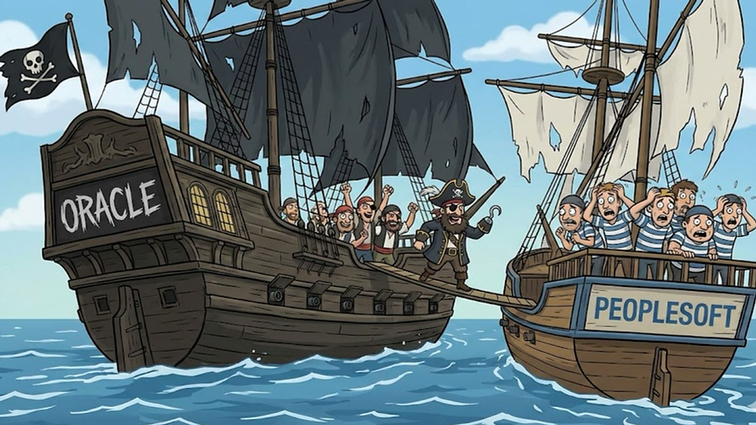

***Example (Oracle):***

Oracle is often called the “Destroyer of Companies” through hostile takeovers because of its ruthless, calculated, and highly effective acquisition strategy, led by the master himself, Larry Ellison. Oracle uses a combination of aggressive strategies to pressure companies into accepting the offer.

Between 2004 and 2010, Oracle spent roughly $40 billion acquiring dozens of rivals in the software industry.  **Oracle vs. PeopleSoft (2003–05):**

* This is one of the most famous hostile takeovers, lasting over 18 months. PeopleSoft announced a merger with J.D. Edwards, after which Oracle made a low $16-per-share offer to PeopleSoft’s shareholders.
* Larry Ellison publicly stated that if Oracle succeeded in the takeover, it would discontinue PeopleSoft’s products. To counter this threat, PeopleSoft launched a customer assurance program offering customers compensation of up to five times their license fee if Oracle acquired the company.
* Eventually, sustained pressure forced shareholders to surrender, and the takeover was completed at a value of $10.3 billion, with Oracle paying $26.50 per share.

*Hostile takeovers are the ultimate expression of “survival of the fittest” in the corporate world. It shows that ownership for the company isn’t just bought – it’s taken.* Authored

By: [Aryaveer Batra](https://www.linkedin.com/in/aryaveer-batra-64819a317/)

**From Compliance to Competitiveness: The Green Economy’s Effect on Corporate India and ESG Reporting**



**Green Economy and ESG Accounting: Growing Sustainability**

A green economy, or sustainable economy, is a model that fosters growth while protecting natural resources and ecosystems for future generations. ESG (Environmental, Social, and Governance) reporting details how companies disclose sustainability practices.



**Understanding the Green Economy**

A green economy advances sustainability by balancing environmental protection, social well-being, and economic growth. Unlike traditional models that overlook ecological costs, the green economy model prioritizes lower carbon emissions, reduced waste, resource conservation, and renewable energy.

*For instance:*

India has seen growth in solar power generation, enabled by projects such as the Rewa Solar Plant in Madhya Pradesh, which has reduced carbon emissions and created thousands of jobs in the installation, maintenance, and manufacturing of solar equipment.

Tata Motors and Ather Energy are expanding electric-vehicle adoption, reducing reliance on fossil fuels, and creating new markets and skills.

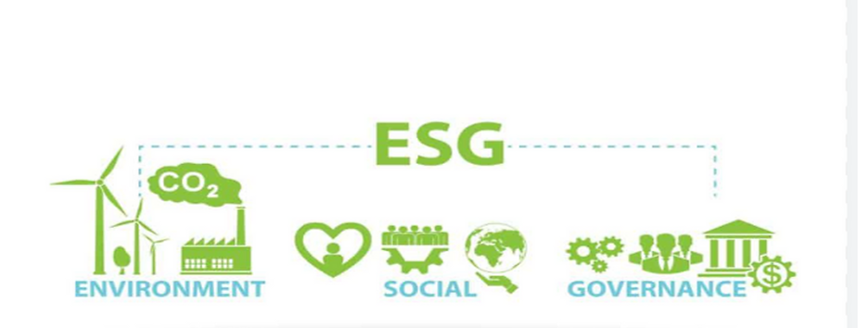

**The Role of ESG Accounting:**

ESG reporting allows companies to evaluate sustainability using measurable data. It covers environmental, social, and governance issues, enabling stakeholders to make informed decisions.

• Environmental indicators also include energy and water utilisation, waste generation, existing pollution, and carbon emissions.

• Social measures, which include employee welfare, workplace diversity, community development, and human rights.

Governance indicators include board diversity, ethical leadership, transparency, and compliance.

ESG Reporting for a Green Economy:

ESG reporting translates sustainability goals into practice. It enables companies to report on progress in sustainable development and identify required improvements.

For example:

A textile company may report on issues related to water conservation, such as the efficiency of dyeing processes, or on the proportion of cotton sourced from organic farms.

A manufacturing firm may seek to transition from coal-based energy to solar and report the exact degree of carbon-emission reduction.

This transparency boosts investor trust, attracts responsible consumers, and drives innovation among companies.

**ESG Issues in Green Economy Projects:**

• Better Decision-Making

ESG data highlights risks early. For instance, a water-intensive company may anticipate scarcity and adopt recycling technology.

• Higher Investor Confidence

Investors today prefer sustainable companies. At Tata Power, we focus on renewable energy and have attracted increased interest from ESG-focused funds.

• Regulatory Compliance

India’s corporate social responsibility and sustainability reporting (BRSR) rules require ESG accounting for listed companies.

• Competitive Advantage

Companies that prioritise sustainability attract more eco-conscious customers and report greater success. For example, HUL’s water-saving and plastic-reduction programs have improved its market standing.

• Long-Term Resilience

By addressing environmental and social risks, companies build resilience against crises such as climate disruptions or supply chain interruptions.

**Challenges**

ESG offers value but faces challenges, including inconsistent standards, poor data quality, and challenges in measuring social impact.

However, these issues may be overcome by:

• Adopting international frameworks like GRI or SASB.

• Through the use of AI-based sustainability tracking tools.

• Training staff on the integration of ESG into day-to-day business.

Companies should not view ESG accounting as a checkbox exercise. Instead, they must integrate it into business strategy and organisational culture.

**Conclusion:**

The green economy promotes growth while prioritising people and the planet. For corporate India, this transition moves from compliance to competitive edge, creating lasting value for the environment, society, and economy.

**Authored by:** [**Ritika Malani**](https://www.linkedin.com/in/ritika-malani/)**,** [**FLC**](https://www.linkedin.com/company/finance-leadership-cell-dps-byc/posts/?feedView=all)

**Advanced Derivatives: Swaps & Option Exercise Styles**

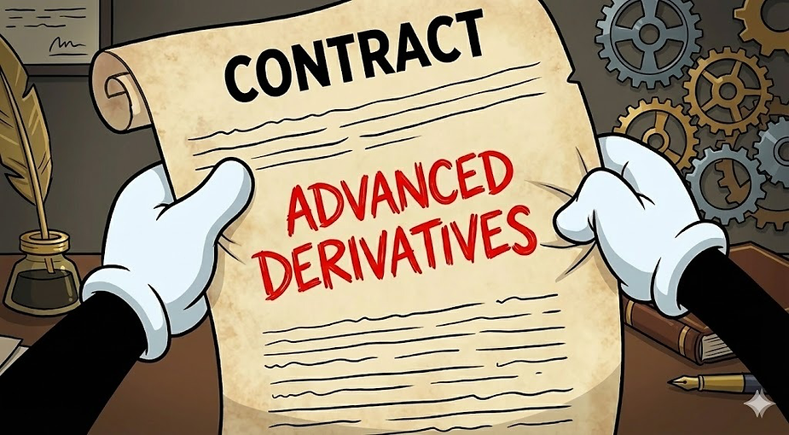

A swap claim refers to the contractual right to receive net payments under a swap agreement. It is more of a legal concept that describes the enforceable obligation owed by a counterparty during the life of the swap or upon default or early termination.

**Interest Rate Swap Example:**

A company with a $100 million floating-rate loan (SOFR + 1.5%) wants stable interest costs, so it enters into a swap in which it pays 4% fixed and receives SOFR.

If SOFR for a payment period is 3.8%, the company:

• receives 3.8% × 100M

• pays 4.0% × 100M

Net settlement = 0.2% × 100M = $200,000 owed by the company.

Here, the company has a claim on the floating payment, and the bank has a claim on the fixed fee. The swap claim is the net difference.

**Cross-Currency Swap Example:**

A European firm enters a EUR/USD swap, trading €46M for $50M and reversing it at maturity. Each quarter, both sides make interest payments. For example, the company pays $625,000 while receiving €425,500. Each party holds a claim against the other, and net settlement may require currency conversion.

Option Claims

An option claim is a contingent claim, meaning it has value only if certain price conditions are met. Options give a right, not an obligation, which is why buyers pay a premium.

• A call option grants the right to buy the asset at the strike price and gains value when the asset price rises.

• A put option grants the right to sell and gains value when the price falls.

The premium compensates the seller for taking on this obligation.

**Why is there no premium in futures, forwards, and swaps**

**Forwards**

• Both parties are obligated to transact at maturity at the set price.

• Since no one has a unilateral advantage, no premium is required.

**Futures**

• Also involves mutual obligations, and contracts are marked-to-market daily.

• No upfront payment (other than margin) is needed.

**Swaps**

• They are essentially a series of forward contracts.

• Each side agrees to pay one cash flow in exchange for another.

• Both have obligations → no premium.

**American and European Options**

**American-Style Option**

• Can be exercised at any time up to and including the expiration date.

• Gives the holder more flexibility.

• Because of this flexibility, American options are usually worth more than European options.

Example:

You buy an American call option on Apple stock expiring in 3 months. If the stock price jumps tomorrow, you can exercise immediately.

**European-Style Option**

• It can be exercised only at the expiration date, not before.

• Less flexible than American options.

• Often used in index options and some OTC derivatives.

Example:

You buy a European call option on an index. Even if the index rises sharply before expiration, you cannot exercise early—you must wait until expiry.

**Advantages and Disadvantages of Derivatives**

**Advantages**

As the above examples illustrate, derivatives can be a valuable tool for businesses and investors alike. They provide a way to:

• Lock in prices

• Hedge against unfavourable movements in rates

• Mitigate risks. These pluses can often be obtained at a low cost.

**Disadvantages**

Derivatives can be challenging to value because they're based on the price of another asset. OTC derivatives also include counterparty risks that are difficult to predict. Additionally, most derivatives are sensitive to the following:

• Changes in the amount of time until expiration

• Any costs associated with holding the underlying assets

• Interest rates

These variables make it difficult to perfectly match the value of a derivative with the underlying asset. Because the derivative has no intrinsic value, its value comes only from the underlying asset; it’s vulnerable to market sentiment and market risks.

Supply and demand factors can cause a derivative’s price and liquidity to rise and fall, regardless of the underlying asset’s price. Finally, derivatives are usually leveraged instruments and using leverage cuts both ways. While it can increase potential returns, it also makes losses mount quickly.

**Authored by: Paul George,** [**FLC**](https://www.linkedin.com/company/finance-leadership-cell-dps-byc/posts/?feedView=all)

**Foundations of Derivatives: Concepts, Categories & Intuitive Examples**

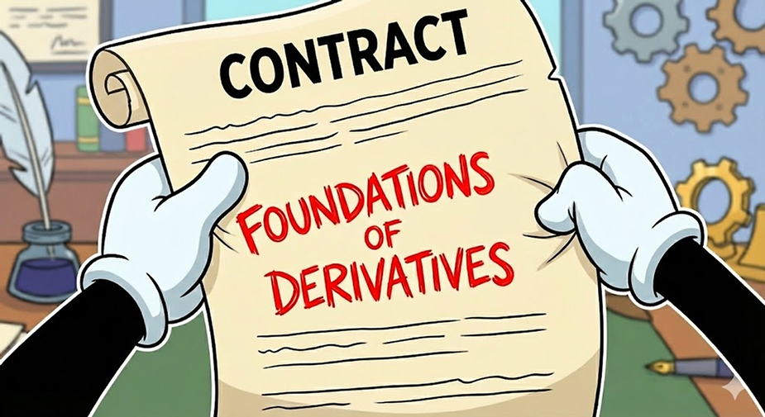

A derivative is a financial contract whose value depends on one or more underlying assets. Traders use derivatives to hedge risk, speculate on price movements, or gain leveraged exposure. These instruments allow traders to reach specific market positions at a lower cost and with greater flexibility than using the underlying assets directly.

Derivatives fall into two main categories: forward claims and contingent claims. Forward claims obligate both parties to follow the agreed terms throughout the contract’s life. Contingent claims, such as options, give the holder the right but not the obligation to buy or sell an asset at a set price before expiration.

**Example to understand derivatives**

An apple farmer expects a harvest in 3 months, and fears apple prices might fall. A juice factory needs apples in 3 months, and worries prices might rise, increasing its costs.

**THE AGREEMENT:**

To protect themselves against price fluctuations, the farmer and the factory enter into a forward contract today. They agree that in 3 months, the factory will buy 1,000 kilograms of apples at a fixed price of $2 per kilogram from the farmer.

This contract is a financial derivative, because its value is derived from the future price of apples.

**Let's assume the CASE OF the MARKET PRICE OF $2.50/KG.**

The factory benefits: It pays only $2/kg, lower than the market price. The farmer misses out on the higher price he could have gotten.

The underlying asset is apples. The derivative is the futures contract based on the price of apples. Both parties use the contract to manage risk. The farmer protects against falling prices, and the factory protects against rising prices.

**The most used derivatives are :**

**A futures claim** arises from a standardized futures contract, an agreement between two parties to buy or sell an asset at a predetermined price on a future date. Futures are traded on exchanges, and traders use them either to hedge price risk or to speculate.

A central clearing house (CCP) stands between buyers and sellers. The CCP guarantees performance by acting as the buyer to every seller and the seller to every buyer, thereby reducing counterparty risk. Futures are also marked to market (MTM) daily, meaning gains and losses are settled in cash each day as the contract value changes.

**A forward claim** works similarly but occurs in over-the-counter (OTC) forward contracts. Forwards are private agreements, not standardized, and allow complete customization of terms, size, maturity, and settlement method. Because no CCP is involved, each party bears the counterparty risk. Forward claims reflect the obligation of each side to perform under the agreed contract at maturity.

**A swap claim** refers to the contractual right to receive net payments under a swap agreement. It is more of a legal concept that describes the enforceable obligation owed by a counterparty during the life of the swap or upon default or early termination.

*If you’d like to explore the more advanced side of derivatives, including how swaps work, why option styles matter, and what risks traders must watch out for, you can continue reading in the following article,* [*click here.*](https://www.themorrigan.in/post/advanced-derivatives-swaps-option-exercise-styles)

**Authored by: Paul Thomas George,**[**FLC**](https://www.linkedin.com/company/finance-leadership-cell-dps-byc/posts/?feedView=all)**.**

**Hedging Made Simple: How Smart Investors Stay Safe**

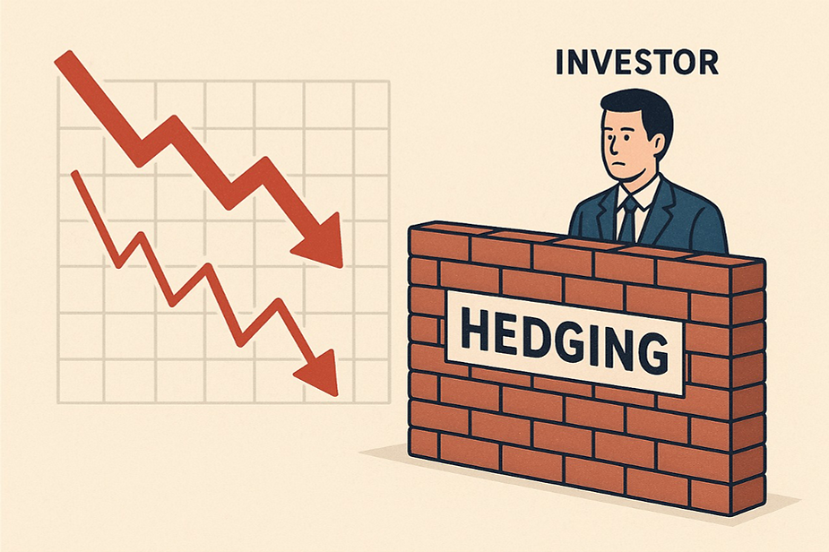

Risk is often viewed as a simple dilemma – win or lose. However, professional managers know risk as a complex structure. Suppose you buy car insurance. You don’t want your car to crash, and if it crashes, the insurance will save you from financial ruin. Similarly, when you invest, there is a risk that the investment may result in a loss. It may be due to price uncertainties, global tariffs, economic policies, and other factors.  That’s where hedging comes in. Hedging is not about preventing losses or making money; it is about avoiding losses and preserving cash flows. When you hedge, you are essentially playing with the possibility of maintaining your gains.

Many traders today seek opportunities to generate profits by hedging on short-term trades, whereas hedge fund managers utilise hedging to preserve capital. Hedging is typically a defensive manoeuvre rather than an aggressive trading strategy. The core purpose of hedging is to maintain stability and ensure protection from surprise price fluctuations.

***Example:***

Consider a farmer who wants to sell 100 kgs of wheat during the harvest season. If the price of wheat collapses before harvest, the farmer’s income disappears. To avoid this, the farmer would sell wheat futures to lock in a price before harvest. If the price falls, the profit on futures reduces the loss incurred. Similarly, the same approach can be applied to crude oil prices, gold price volatility, currency fluctuations, and commodity price fluctuations.

***Hedging Instruments:***

1.   **Futures:**

A future contract is an instrument that allows the investor to buy or sell an asset at a predetermined/fixed price on a future date. This ensures higher liquidity, allowing investors to enter and exit positions easily. Prices are determined by buying and selling on regulated exchanges, so that everything is transparent. These are standardised contracts, and all parties to this contract should honour the agreement.

A fixed premium is required to enter into the contract, which could burden the investor's cash flow while exposing them to a higher-risk environment.

***Example:***

Suppose you are an oil company and you want to import crude oil 3 months from now for refining. But the prices in the market are very volatile, and you don’t like the prices to rise by the time you have to make the purchase. By entering into a crude oil futures contract, you can lock the price now and make the purchase later at the locked price. If the price of crude oil rises in the next 3 months, you will buy it at a discount. But if the price falls, you buy the crude oil at a premium.

2.   **Options:**

Options are similar to futures, but they give you the right (not the obligation) to buy or sell the asset. This provides the investor with flexibility and can help them exit unprofitable situations. This contract also allows you to set custom lot sizes, strike prices, and expiry dates. However, this does not mean completely risk-free. Entering into an options contract requires an upfront payment, known as the premium.

***Example:***

Consider that you want to buy gold but are worried about the price rising. So, you enter into a gold options contract to reduce the risk of the price going up. If the price goes up, you exercise the contract and buy gold at the agreed price. But if the price goes down, you don’t exercise the contract and buy the gold at the market rate. The only loss in this situation would be the premium paid.

3.   **Forwards:**

A forward contract is the same as a futures contract. Unlike futures contracts, forwards are traded on the OTC (Over-the-counter) market, which is not regulated by any statutory body. These contracts can be customised to meet the investor’s specific needs.

These types of contracts carry counterparty risk (i.e., one of the parties can default). These contracts are also not regulated, so no protection is guaranteed against unfair practices.

***Example:***

Tata Consultancy Services earns most of its income from US companies. They enter into a forward contract to exchange dollars at a fixed rupee rate. This ensures that they are safe from currency appreciation/depreciation.

4.   **Swaps:**

Swaps are an exchange of cash flows between two parties. These are primarily used for interest rates and currency swaps.

***Example:***

Suppose A has a floating-rate loan but wants guaranteed fixed payments. B, on the other hand, has a fixed-interest-rate loan but wants floating payments for a chance at earning some profit. Both parties enter into a swap contract. A gets fixed rates from B; B gets floating from A. Both parties get what they wanted without changing their loans.

***Conclusion:***

These types of instruments are just some of the ways that an investor can practise hedging. Hedging serves as a disciplined approach to mitigate the risk and uncertainty associated with a specific investment. It can be viewed as an ongoing process for monitoring a person’s portfolio. Investors can use hedging to stabilise their cash flows, protect capital and ensure that their returns are protected.

**Authored by:** [**Aryaveer Batra**](https://www.linkedin.com/in/aryaveer-batra-64819a317/)

**The Strange World of Negative Interest Rates**

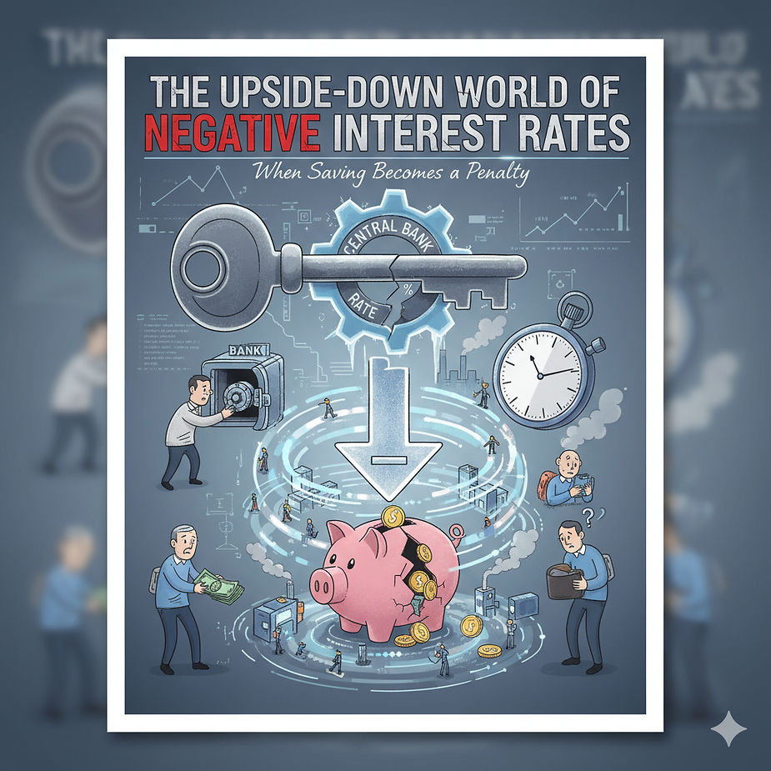

When the word interest rate comes to mind, we usually think of paying an extra amount on a loan or earning returns on savings. Now imagine if the bank charges us to keep money in our own account. Sounds absurd, right? Well, this is the strange reality of negative interest rates, a concept that turns the usual rules of finance upside down.

A negative interest rate occurs when the central bank sets the benchmark rate below 0. In simpler terms, instead of collecting interest on deposits, commercial banks will actually pay for the privilege of storing reserves at the central bank. This burden will then fall on the businesses and, in some instances, on everyday customers. A negative interest rate is used to encourage money to flow back into the economy during periods of weak growth or deflation.

Central Banks use negative rates to encourage spending and investment. When the interest rates become negative, saving money would become costly. This means that the banks, which would face penalties for hoarding cash, are encouraged to lend more. Households and companies would also have a stronger incentive to spend or invest instead of watching their savings shrink.

For example, after the global financial crisis of 2008 and the Eurozone Debt Crisis, countries such as Switzerland, Denmark, and Japan faced sluggish growth and persistent deflationary pressures. Their traditional monetary system had been exhausted and became no longer sufficient; these countries adopted negative interest rate policies as a last resort to revive their economies.

The impact of a negative interest rate on the economy is complex and often considered controversial. On the positive side, it can lower borrowing costs, which can encourage business expansion, consumer spending, and housing markets. Export-driven economies, such as Japan and Switzerland, benefited from lower interest rates, which weakened their currencies and made their products more competitive in foreign markets.

 Savers, especially retirees, see their wealth diminish because they earn little or nothing on the deposits, and in some cases even lose money. Pension funds and insurance companies struggle to generate stable returns, which can threaten financial security in the long term. Banks would also suffer as their profit margins slim, which can ironically reduce the lending capacity. Sometimes, people may even react by saving more aggressively, trying to recoup the lost value, which defeats the entire purpose of the policy.

What makes negative rates fascinating is their psychological effect. For centuries, interest has been seen as a reward for saving. Turning it into a penalty and making saving feel like a punishment goes against people’s normal financial behaviour. According to a 2022 Swiss National Bank survey, people preferred storing physical cash in vaults instead of keeping it in the bank.

Negative rates have sparked debates on a global level about the limits of monetary policies. Critics argue they are only a temporary fix that hides deeper economic issues, while Supporters see them as a creative tool in an era where traditional financial levers are insufficient.

Negative rates remain one of the boldest experiments in modern economics as they question traditional assumptions about lending, saving, and investing. Whether they succeed or fail, they have already forced economists and policymakers to think differently about how money works. In uncertain times, they show that even the most basic financial principle, like interest, can be rewritten.

**Authored by: Adithya Jayan,** [**FLC**](https://www.linkedin.com/company/finance-leadership-cell-dps-byc/posts/?feedView=all)

**Get rich quick" the truth about Ponzi schemes**

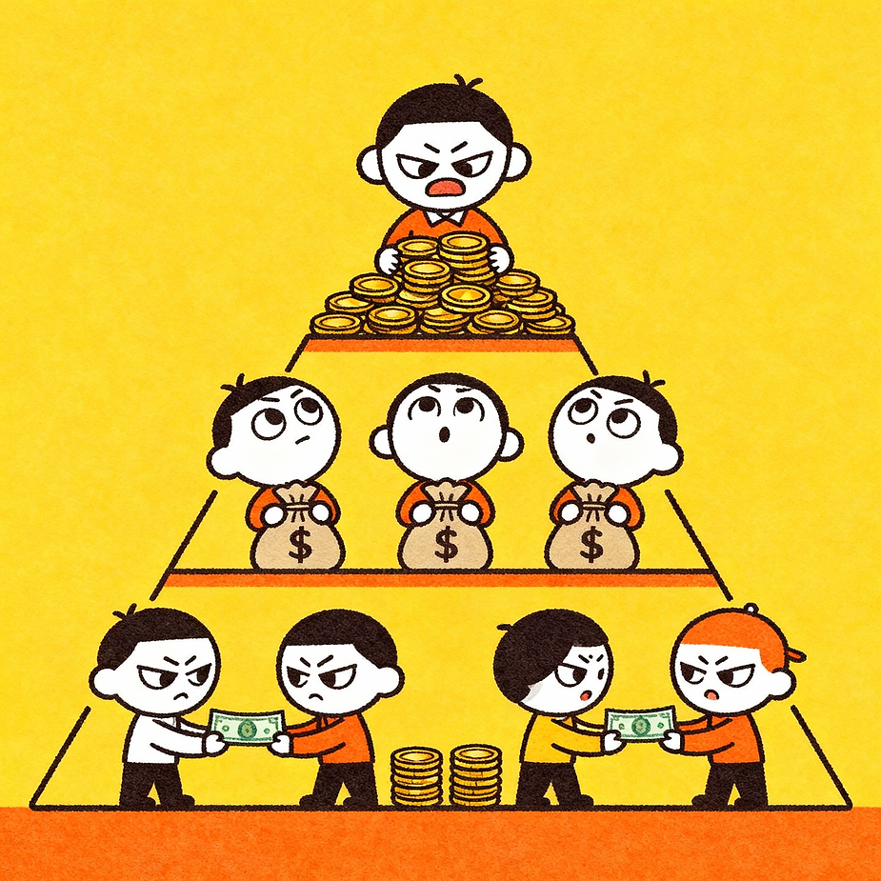

People yearn for power and influence—and often, all it takes is a piece of bond paper, also known as ‘money’. You've probably heard the saying, “Money is the root of all evil.” Ironically, the ones plotting to take yours usually say that. Stealing money usually meant robbing a bank; in modern times, con artists tend to use a less honourable and direct approach: ‘financial scams’

The pyramid of deceit: The Ponzi scheme is one of the most sinister financial scams, having cost victims billions and shattered countless lives. Unlike mutual fund managers, who pool resources and grow them through investing in financial instruments, a Ponzi scheme thrives by luring new investors and using their money to pay off earlier ones, until the entire structure collapses.

The Ponzi scheme is designed with a hierarchical structure, comprising levels such as Top, Middle, Bottom, and the Head. The head of the pyramid would be the founder of the scheme, who lobbies people for money. The initial stage of the scheme involves lobbying for funds from High Net Worth Individuals (HNIs) or inventors who are willing to invest a high volume. This, in turn, is expected to encourage mid-tier investors to participate in the scheme, as they assume profitability is a guarantee due to the large pool of investment. To continue the debt, the head of the scheme will use the money from the mid-tier investors to pay off the HNIs.

The pyramid will eventually crumble, as its survival depends on constant upward growth, which is unrealistic; soon, investors will want to see results and withdraw. Due to cash shortages (since the fund pool is not growing), investors will not be repaid, while the head of the Ponzi scheme will effectively remain wealthy, taking a commission from every investor.

Even in 2025, Ponzi schemes are rampant, but they all pale in comparison to the legendary Bernie Madoff Ponzi scheme of 2008…

**Authored By:** [**Srikrishna Ved Kodakalla**](https://www.linkedin.com/in/srikrishna-ved-kodakalla-co-founder/)